# EECT7327: Homework 2

# A x MSPS segmentation DAC with Dynamic Element Matching and Gray code nested structure

Devangsingh Sankhala (dgs150030), Bhargav Patel()

## Introduction

## Conventional current steering DAC

## Methods of performance enhancement

### Segmentation

### Dynamic Element Matching (DEM)

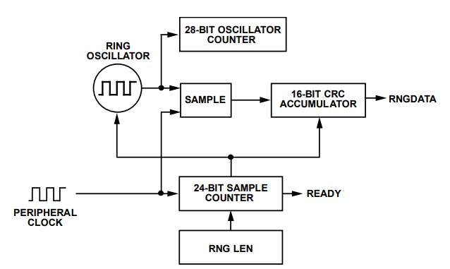

### Gray code DAC topology

## Optimization of segmented DAC using DEM and Gray code

## Simulation results

### INL/DNL

### SNDR

### SFDR

### ENOB

### ERBW

### THD

### Power

### Figure of merit (FOM)

## References